Calif. governor signs bill allowing college athletes to sign endorsements
In ripping the NCAA, Gov. Gavin Newsom said: "Colleges reap billions from student athletes but block them from earning a single dollar. That’s a bankrupt model."

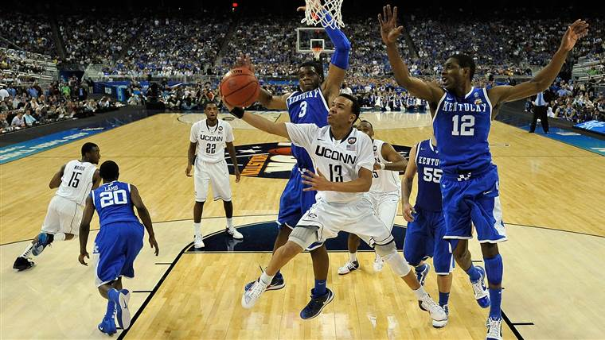

Sept. 11, 201902:18
Sept. 30, 2019, 10:18 AM CDT / Updated Sept. 30, 2019, 11:54 AM CDT
By David K. Li
NBC News: https://www.nbcnews.com/news/us-news/california-governor-signs-bill-allowing-college-athletes-get-paid-n1060321
Calling the forced amateurism of student-athletes "a bankrupt model," California Gov. Gavin Newsom signed a first-in-the-nation bill Monday that clears the way for college players to be paid from endorsement deals.
The legislation allows student-athletes to sign endorsement deals and prohibits the governing body of college sports, the National Collegiate Athletic Association, and the schools from banning those compensated athletes.
NCAA rules strictly prohibit athletes from profiting in any way from their sports, and the law would still bar schools from directly paying athletes.
The new regulation is scheduled to start in 2023.
"Colleges reap billions from student athletes but block them from earning a single dollar. That’s a bankrupt model," Newsom tweeted after signing the bill.
The NCAA acknowledged in a statement Monday that its current regulations on amateurism will need to change, but said California's new law won't help.
"As a membership organization, the NCAA agrees changes are needed to continue to support student-athletes but improvement needs to happen on a national level through the NCAA's rules-making process," the governing body said.
"Unfortunately this new law already is creating confusion for current and future student-athletes, coaches, administrators and campuses and not just in California."
Newsom signed the bill while appearing on NBA icon LeBron James' HBO show, "The Shop: Uninterrupted."
The governor predicted it would prompt dozens of other states to pass similar legislation and force the NCAA's hand.
"It's going to change college sports for the better by having now the interests finally of the athletes on par with the interests of the institutions," Newsom said. "Now we're re-balancing that power arrangement.
James, who went pro straight out of high school, urged the NCAA to come to the bargaining table and find a way to compensate athletes who generate millions of dollars, especially in football and basketball.
"NCAA, you got the next move," James wrote on Instagram. "We can solve this for everyone!"
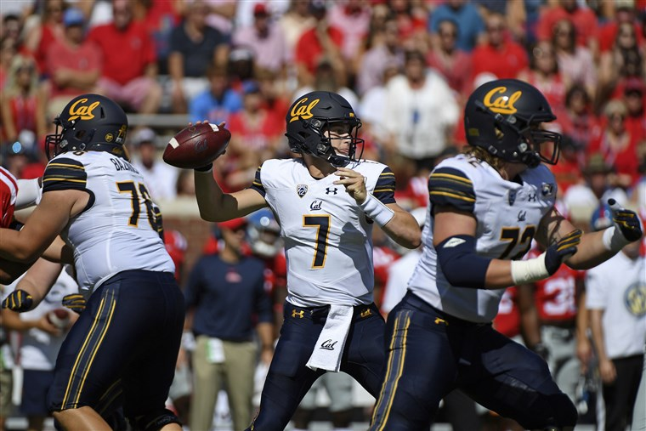
California quarterback Chase Garbers throws the ball against Mississippi in Oxford, Miss., on Sept. 21, 2019.Thomas Graning / AP file
Newsom's signature on Monday served as one more step toward the end of free labor in college sports, according to University of Chicago economics professor Allen Sanderson.
"The NCAA's 100-year model is not going to survive another 10 years, there's just too much money involved," Sanderson, who specialized in sports economics, told NBC News.
"How it's going to exactly play out, I don't know. It's a like a fumble on the ground and who is going to recover it. I'm just pretty sure that the NCAA is not going to end up with the ball."
While the NCAA is the governing body of college sports, membership is voluntary. So conceivably, if schools are forced out of competition by the NCAA, they could simply opt out to form their own new leagues.
The Golden State is home to dozens of schools that play top-flight Division I sports, including Pacific-12 Conference institutions such as the University of Southern California, Stanford University, the University of California, Los Angeles, and the University of California, Berkeley.
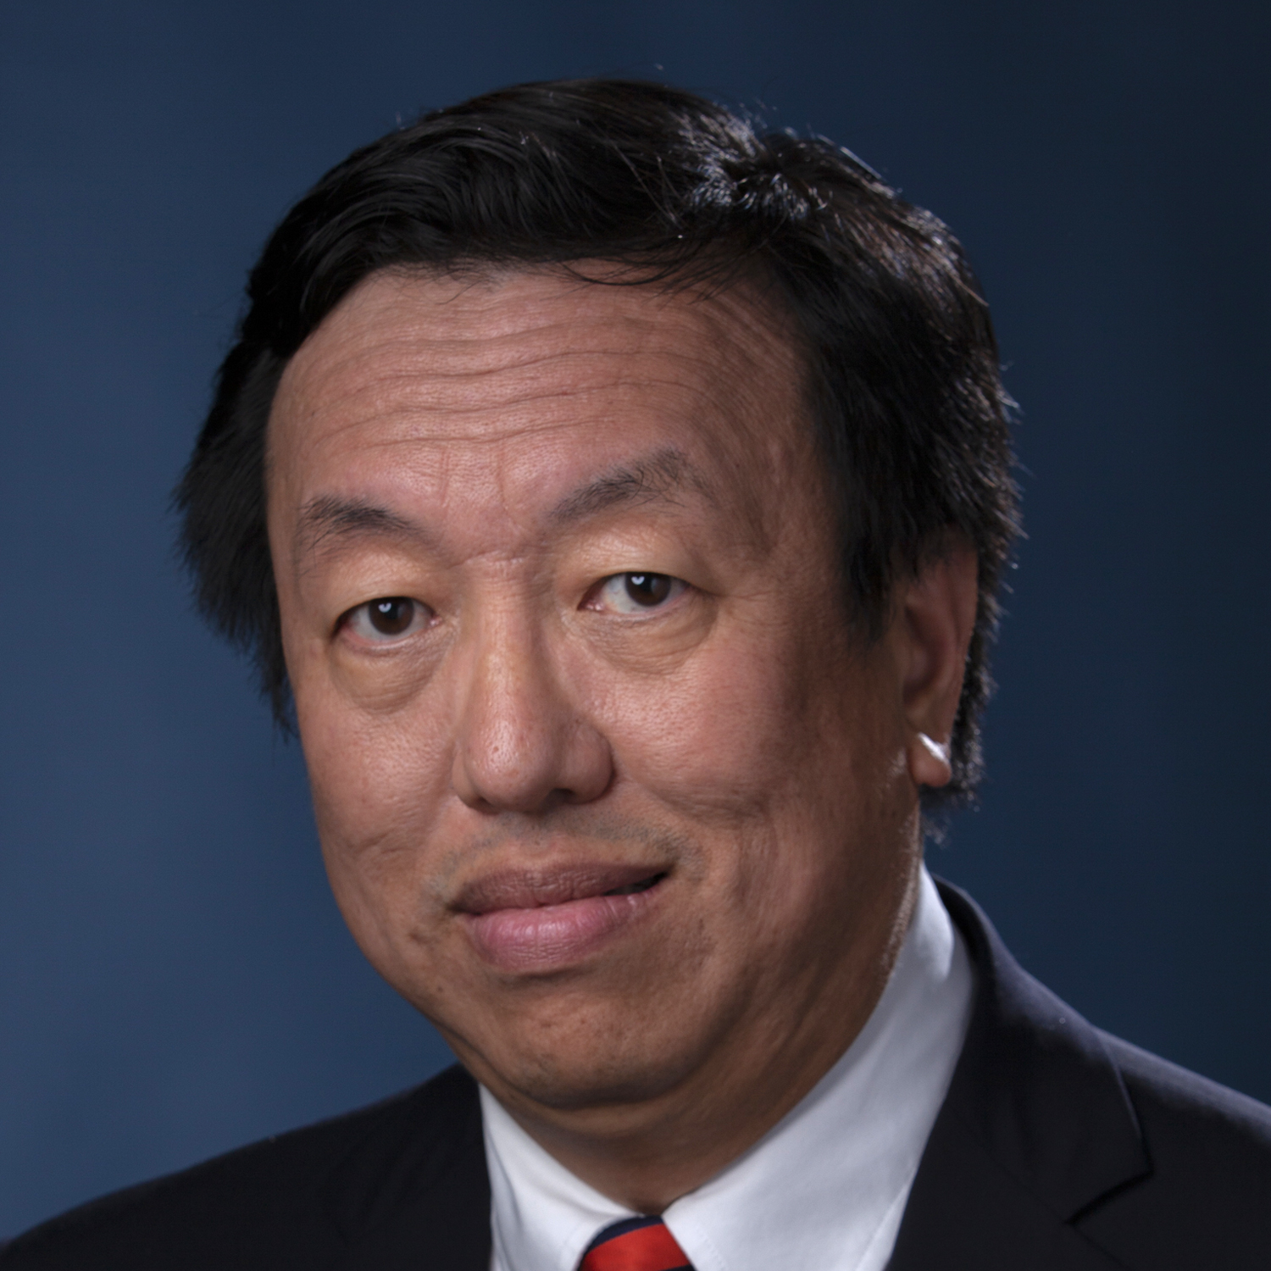David K. Li
David K. Li is a breaking news reporter for NBC News.

